**“IOT based smart laboratory”**

**Er. Vinit Tirnagarwar**

E&TC Department, AISSMS IOIT Pune, India.

***Abstract****— V The education system is always an important need for development and growth. an important factor in the education system is infrastructure the better the infrastructure you have better you can learn. Infrastructure will have its own resources it may get utilized better or may not. in most of the conventional class or laboratory cases utilization is minimal. For better resource utilization and smart management of conventional labs/classroom, we are proposing this system.*

*This paper presents a smart laboratory system for an automatic and efficient lab management system .In this system authorised personal only make the changes in default automation settings, main purpose of this project is to provide an efficient way of power saving and lab monitoring. Continuously temperature and crowd motion also attendance are monitored. According to the above parameter relays are switched to save power. Student attendance and temperature of laboratory are continuously stored in connected mass storage device. Complete implemented system provides a better and smart way of laboratory management.*

*Present paper describes a model, which is done by using several software’s like proteus python IDE and many more.A prototype of the proposed smart lab monitoring system is built and tested to analyze the performance of the system.*

**I. INTRODUCTION**

In recent years automation is a trend at domestic and industrial level. Commercial building like hospital colleges and labs are also using automation luxuries for efficient utilization of resources. There are so many things need to be maintained in commercial labs like lighting, temp control, monitoring and attendance etc. All this system are become automotive at individual level. This can be centralised control and more efficient by implementing mentioned system.

Smart Laboratory is an automation system to facilitate the control of the electronic appliances located in a laboratory depending on the sensor parameter. In the present study, we developed a Smart Laboratory system using a Raspberry Pi b+ ARM controller board, in which the lamps also maintain attendance. several sensors like, fingerprint for authentication and attendance purpose, Temp sensor to maintain temp, and motion detectors are fitted to get good light management system according to availability of students in the lab.

Complete system is enabled with I.O.T which is Internet of things the access to the internet is provided by R-pi where it is acting as a gateway and uploading the information to the server also in back up data is available in mass storage device

**II. BLOCK DIAGRAM AND DESCRIPTION.**

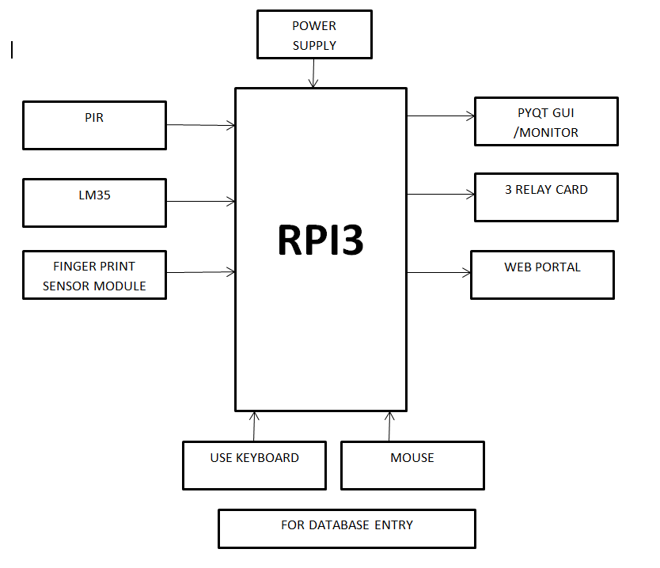

**Fig 2.1: Block diagram of Model**

* R-pi 3- Raspberry-pi is a 32 bit ARM based controller board. Booted by EOS to make and run programs over it it is highly capable in networking and data computing areas due to OS support.
* PIR(proximity Sensor)- PIR sensors detects the motion and raise output voltage. It is used for effective lighting system. If someone is available in particular area of lab only those lights and fans will be on. It work on infrared proximity system
* Finger print sensor- optical finger print sensor is specifically communicates with the main controller for attendance monitoring and recording for further analysis purpose. In additional case it is also used for authority to main system access.

* LM35 –LM35 is a temp sensor and transducer.it gives output is analog voltage form LAB live voltage is scanned by temp sensor. The operation and judgement over the temp data is done by R-Pi controller.
* Relay card-an electrical device that controls the high voltage switching were on secondary end we can connect high voltage devices.
* Power Supply- 5v 1amp on board linear power supply is designed which will be directly power up from main and will be sufficient to run all components on the board.

**III. CIRCUIT CONFIGURATION**

**SOFTWARE INFORMATION**

* Simulation software

Proteus V2.0

developed by lab centre electronics

released in 1988,England.

thousands of electronics component library provided.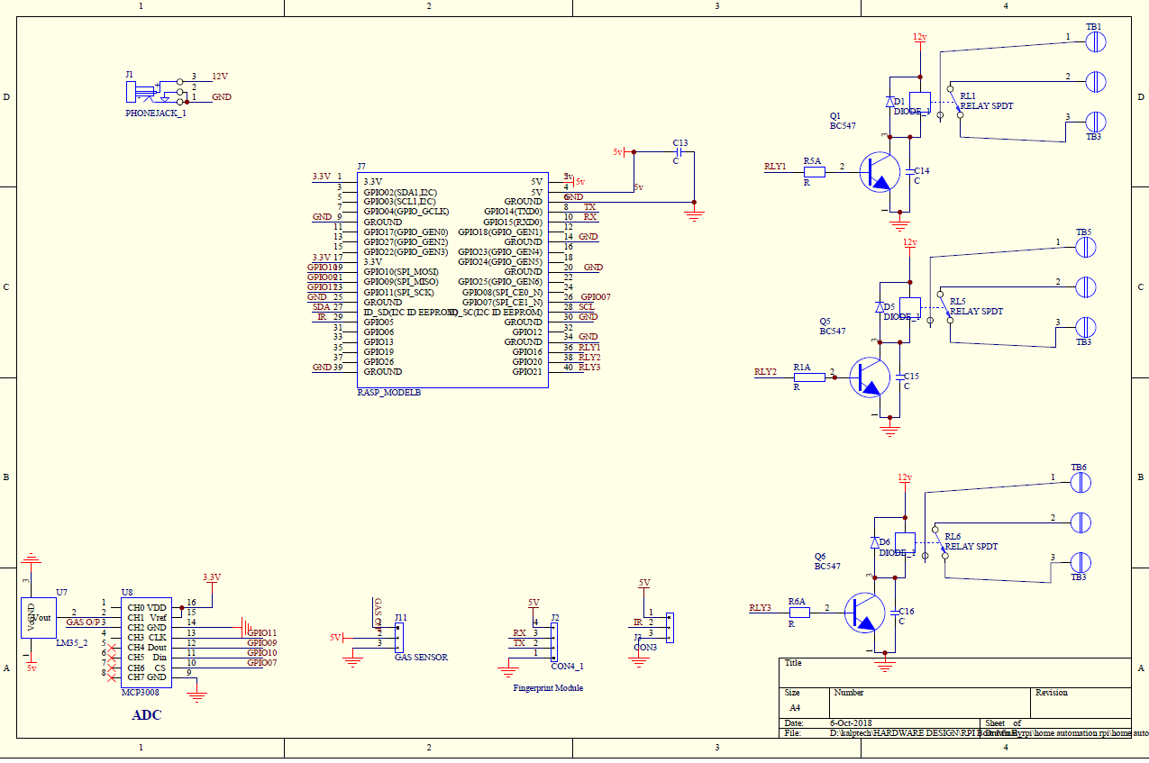

**Fig 3.1:** Simulation Prototyping.

[A]: Model Simulation.

Basic system module is designed on proteus simulation environment for basic module and programming testing, software description are explained as in same section.

Raspberry-Pi is the main controller board. All the other peripheral modules and sensors are connected to it as shown in simulation fig. 3.1. As shown the relay cards are attached to the GPIO(general purpose Input/output). Which will be controlled by the R-Pi as it programmed.

Motion detector sensor and LM35 temp sensors are connected to Analog. Digital pins of Raspberry-Pi board as shown in picture. Master keyboard ,mouse and monitor will be attached to the system for manual authorised approach for user.

**IV. PROTOTYPE MODULE.**

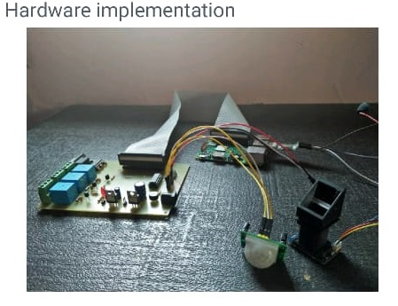

**Fig 3.3: Prototype Module**

Prototype Module is built after circuit simulation and designing is done as shown in fig 3.2.1 by using software simulations result. Prototype module important parts/components are explained as b

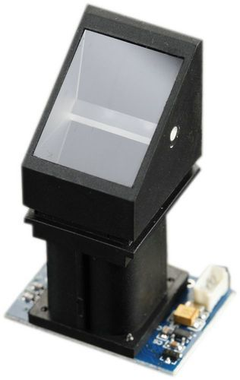

**Fig 3.3.1: Finger Print sensor.**

Module 1: Finger print sensor.

Like optical scanners, capacitive fingerprint scanners generate an image of the ridges and valleys that make up a fingerprint. it does print sensing using light and generates a character data each time it will generate the same data for the same pattern and send it to master controller.

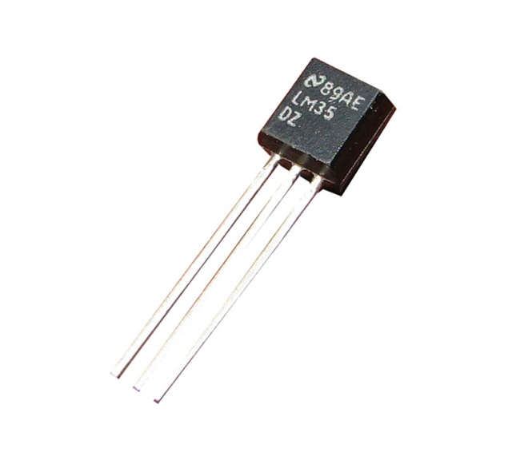

**Fig 3.3.2: LM35 (Temp Sensor).**

Module 2: Temperature sensor.

LM35 is a sensor/transducer which converts analog temperature to electrical output and it is proportional to Degree Centigrade. The electrical analog voltage is output. an LM35 Sensor does not require any external calibration or trimming to provide typical accuracies.

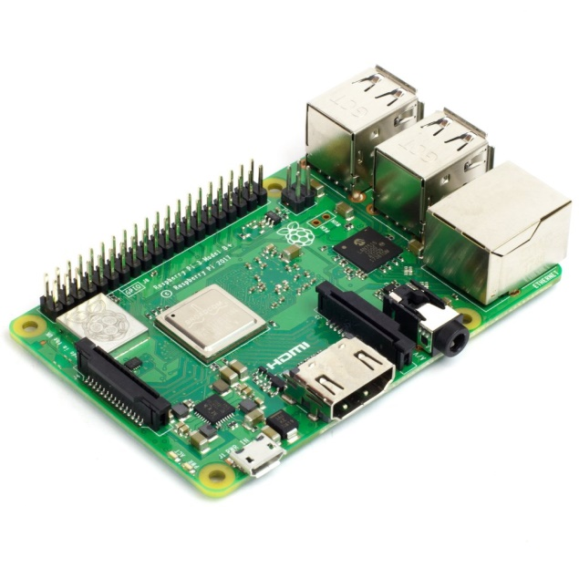

**Fig 3.3.3: R-pi Model.**

Module 3: Raspberry -Pi

The Raspberry Pi is a low cost, 32-bit architecture computer that plugs into a computer monitor or TV, and uses a standard keyboard and mouse. It has capacity to run EOS on its architecture platform. R-Pi gives ability to do multiple operations on vendor and hardware stack. Enables people of all ages to explore computing, and to learn how to program in languages like Scratch and Python.

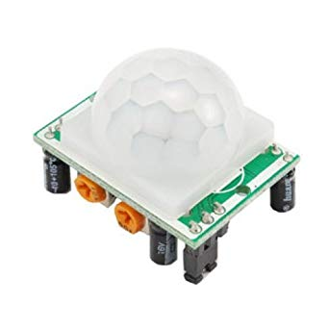

**Fig 3.3.4: Proximity Sensor.**

Module 3: Proximity Sensor.

Proximity sensor works on infrared sensing. It transmit the infrared rays and the rays reflect back from object. If any moment happens then that pattern get disturbed and motion is detected.

**V. WEB PORTAL**

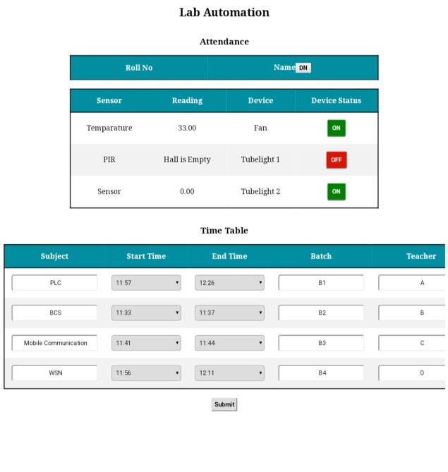

Fig 3.4:Web Portal.

An Online Web portal is provided through R-Pi. This will enable authorized people to do changes in the system and manual override to the system.

**VI. CONCLUSION**

By introducing such a reliable system human intervention is reduced and efficient lab management is done. Power saving is also another concern which will be maintained by system itself. Lab attendance temp monitoring and crowd all data is stored in digital format on SD card for analysis purpose and future expansion of lab.

**VII. REFERENCES**

* M. Poongothai A , Rajeswari P, Muthu Subramanian \Design and Implementation of IoT Based Smart Laboratory" in 2018 5th International Conference on Industrial Engineering and Applications.
* Mary Cherian, Hitesh Kumar \Implementation of a Secure and Smart Lab with Wireless Sensor Network" in international journal of science and research.
* Chunsheng Zhu, Victor C.M. Leung, Lei Shu (2015) \Green Internet of Things for Smart World", IEEE, Volume : 3,Issue : 2, pp.2151- 2162.
* M. A. Razzaque, M. Milojevic-Jevric, A. Palade and S. Clarke, "Middleware for Internet of Things: A Survey," in IEEE Internet of Things Journal, vol. 3, no. 1, pp. 70-95, Feb. 2016